分類帽

Sorting Hat

在這個專案，你會做出一頂分類帽，他會依照你的回答將你分到霍格華茲的其中一個學院。

In this project you will make a Sorting Hat that will put you in one of the Hogwarts school houses based on what you say.

你要和同學一起合作，從書中找一些對話作為範例，拿來訓練電腦辨別不同學院學生的說話風格。

Your class will work together to teach the computer to recognise how students in different houses speak by giving it examples of dialogue from the books.

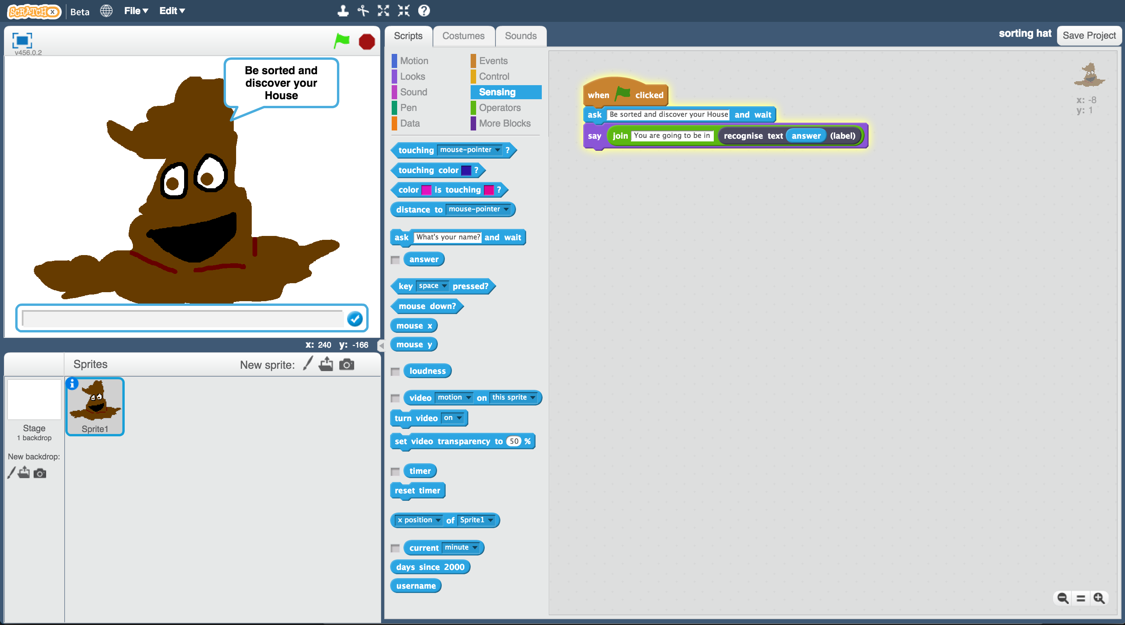

此專案靈感來自Ryan Anderson，他和她的女兒一起做出一頂分類帽！

<https://www.ibm.com/blogs/think/2016/06/watson-sorting-hat/>

The idea for this project came from Ryan Anderson, who made a real-life sorting hat with his daughter!

<https://www.ibm.com/blogs/think/2016/06/watson-sorting-hat/>

**教師教學指南：事前準備**

**Teacher / Group leader instructions : Setup**

這個版本的“分類帽”活動會讓你的學生一起合作訓練一個機器學習模型。如果你需要讓學生單獨操作訓練模型的版本，可以從此處下載：<https://machinelearningforkids.co.uk/worksheets>

This version of the “Sorting Hat” activity will get your class to work together to train a single machine learning model. A version of this activity where students can work individually to each train their own machine learning can be downloaded from <https://machinelearningforkids.co.uk/worksheets>

**目標：建立小組專案與課前準備**

**Objective:** Create a group project & prepare it for use by your class

1. 搜尋網頁：<https://machinelearningforkids.co.uk/>

Go to <https://machinelearningforkids.co.uk/> in a web browser

1. 使用教師帳號登入

Login using your teacher username/password

1. 點選上方清單中的 ”**Projects**” 按鈕

Click on “**Projects**” in the top menu bar

1. 點選 “**+ Add a new project**” 按鈕

Click on the “**+ Add a new project**” button

1. 建立一個專案，命名成 “Sorting Hat”。設定辨識 “**text**”類別，並確認已

勾選“**Whole-class project**”

Create a project called “Sorting Hat”, set to recognise “**text**” and make sure you tick the “**Whole-class project**” checkbox  
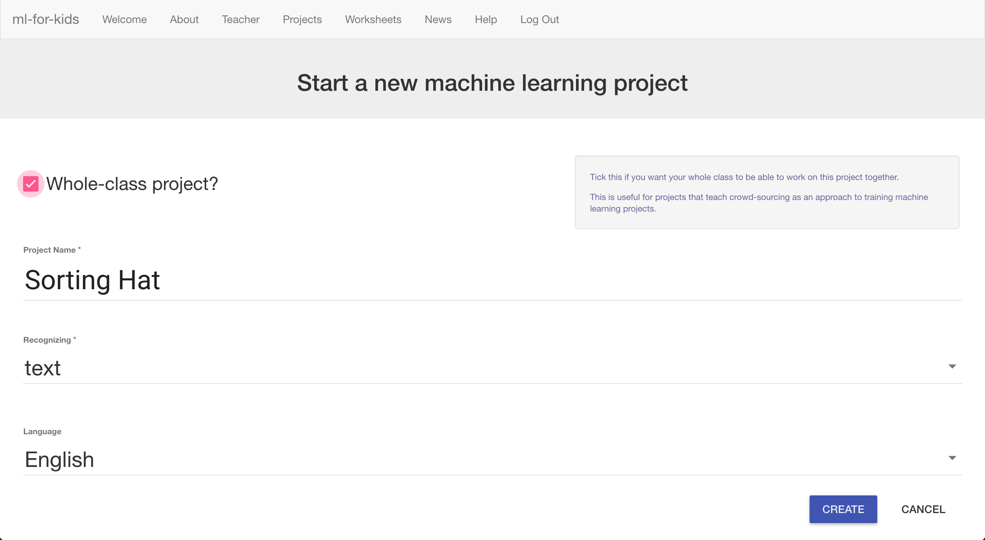

1. 點選 “**Create**” 按鈕

Click “**Create**”

1. 點選專案“Sorting Hat”，再點選 “**Train**” 按鈕

Click on the “Sorting Hat” project in the list, and then click “**Train**”

1. 點選“**+ Add new label**”按鈕來新增四個訓練框：Gryffindor、 Hufflepuff,、Ravenclaw 和 Slytherin

Use the “**+ Add new label**” button to create four training buckets for Gryffindor, Hufflepuff, Ravenclaw and Slytherin  
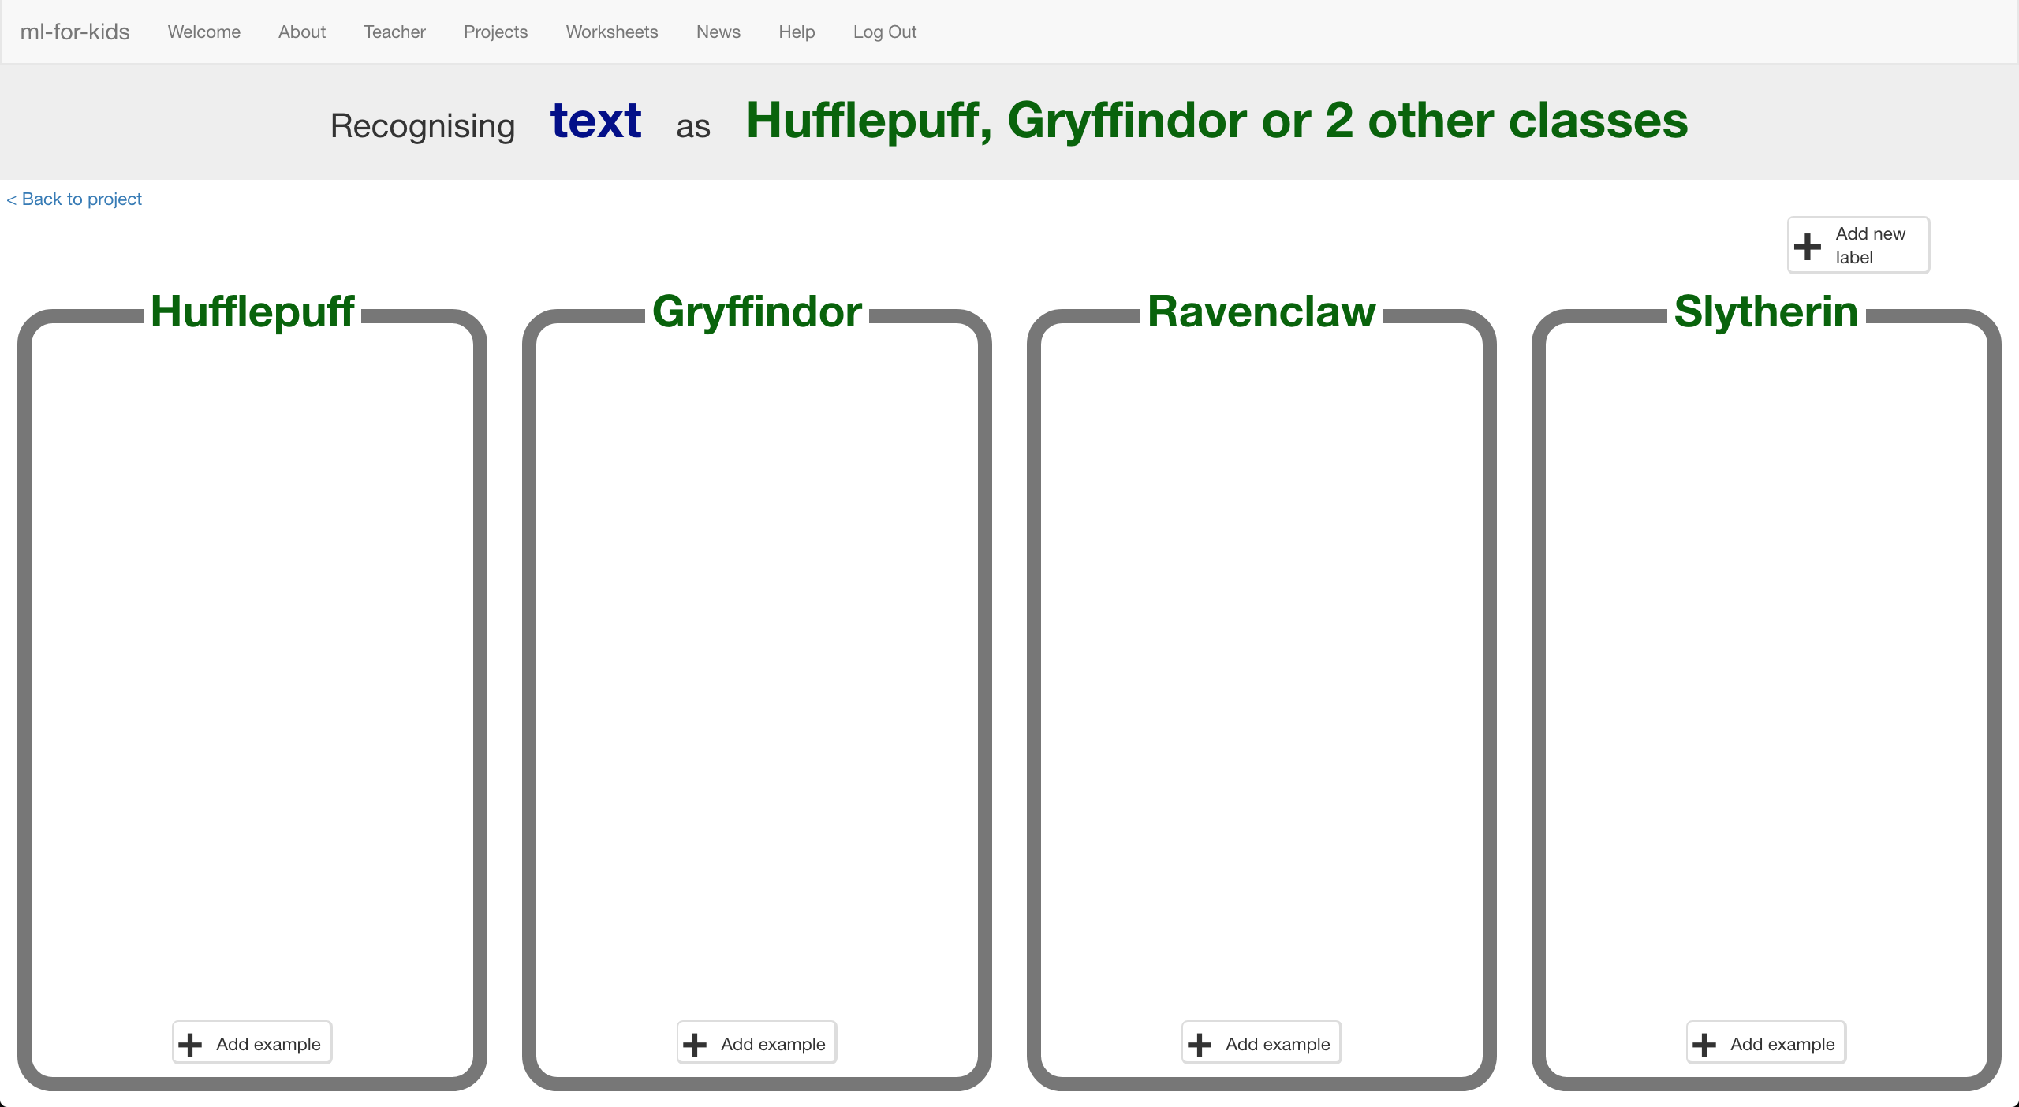

**給學生：實作步驟**

**Student instructions**

1. 你需要幾本哈利波特的書，去圖書館找找吧！

You will need some Harry Potter books for this project.   
*Go to the school library!*

1. 搜尋網頁：<https://machinelearningforkids.co.uk/>

Go to <https://machinelearningforkids.co.uk/> in a web browser

1. 點選 “**Get started**” 按鈕

Click on “**Get started**”

1. 點選“**Log In**”按鈕並登入系統

*如果你沒有帳號，請你的老師幫你建立一個帳號。*

*如果你不記得你的帳號或密碼，請你的老師幫你重新設定一次。*

Click on “**Log In**” and type in your username and password  
*If you don’t have a username, ask your teacher or group leader to create one for you.  
If you can’t remember your username or password, ask your teacher or group leader to reset it for you.*

1. 點選上方清單中的 ”**Projects**” 按鈕

Click on “**Projects**” on the top menu bar

1. 你應該會看一個專案叫“Sorting Hat”，點選此專案

You should see a “Sorting Hat” project created by your teacher. Click on it.   
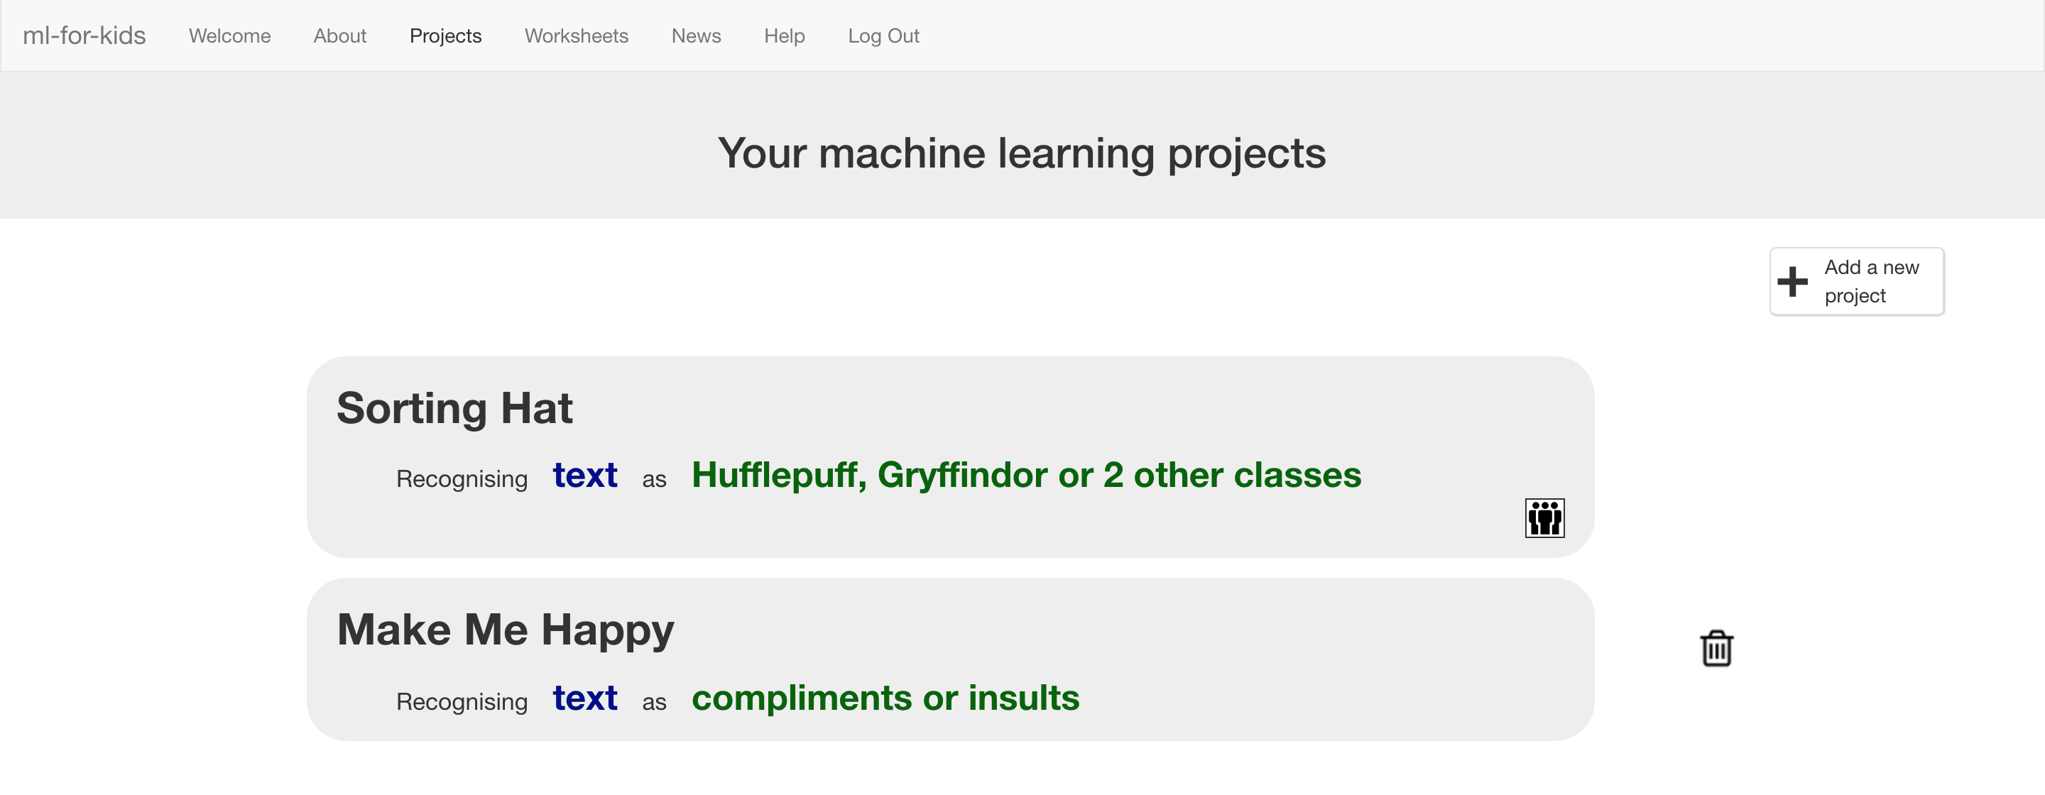

1. 點選“**Train**”按鈕開始搜集訓練電腦用的範例照片

Click the “**Train**” button to start collecting examples of quotes to train the computer with.

1. 你的老師已經幫你準備好哈利波特故事裡四個學院的方框了

Your teacher has prepared training buckets for each of the school houses in the Harry Potter stories.   
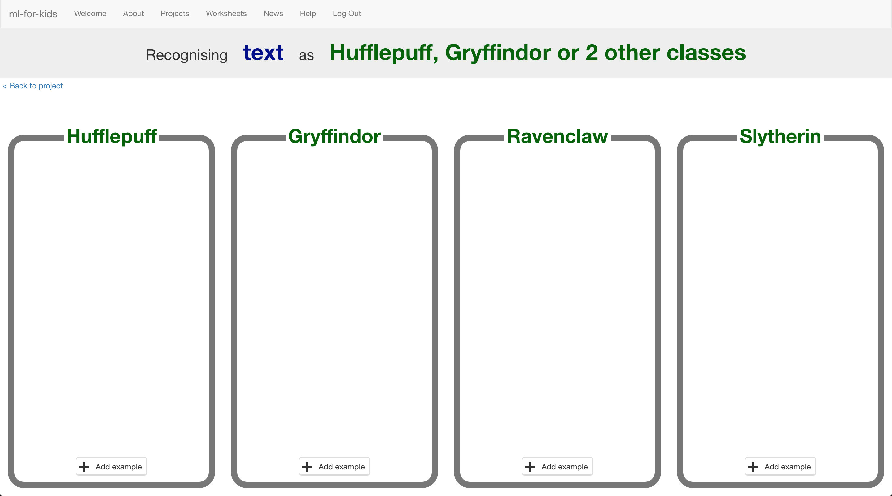

1. 點選“Gryffindor”方框中的“+ **Add example**”按鈕，輸入一句哈利波特說過的話，點選“**Add**”。

Click on the “+ **Add example**” button in the “Gryffindor” bucket. Find a quote by Harry Potter and type it into the box. Click “**Add**”  
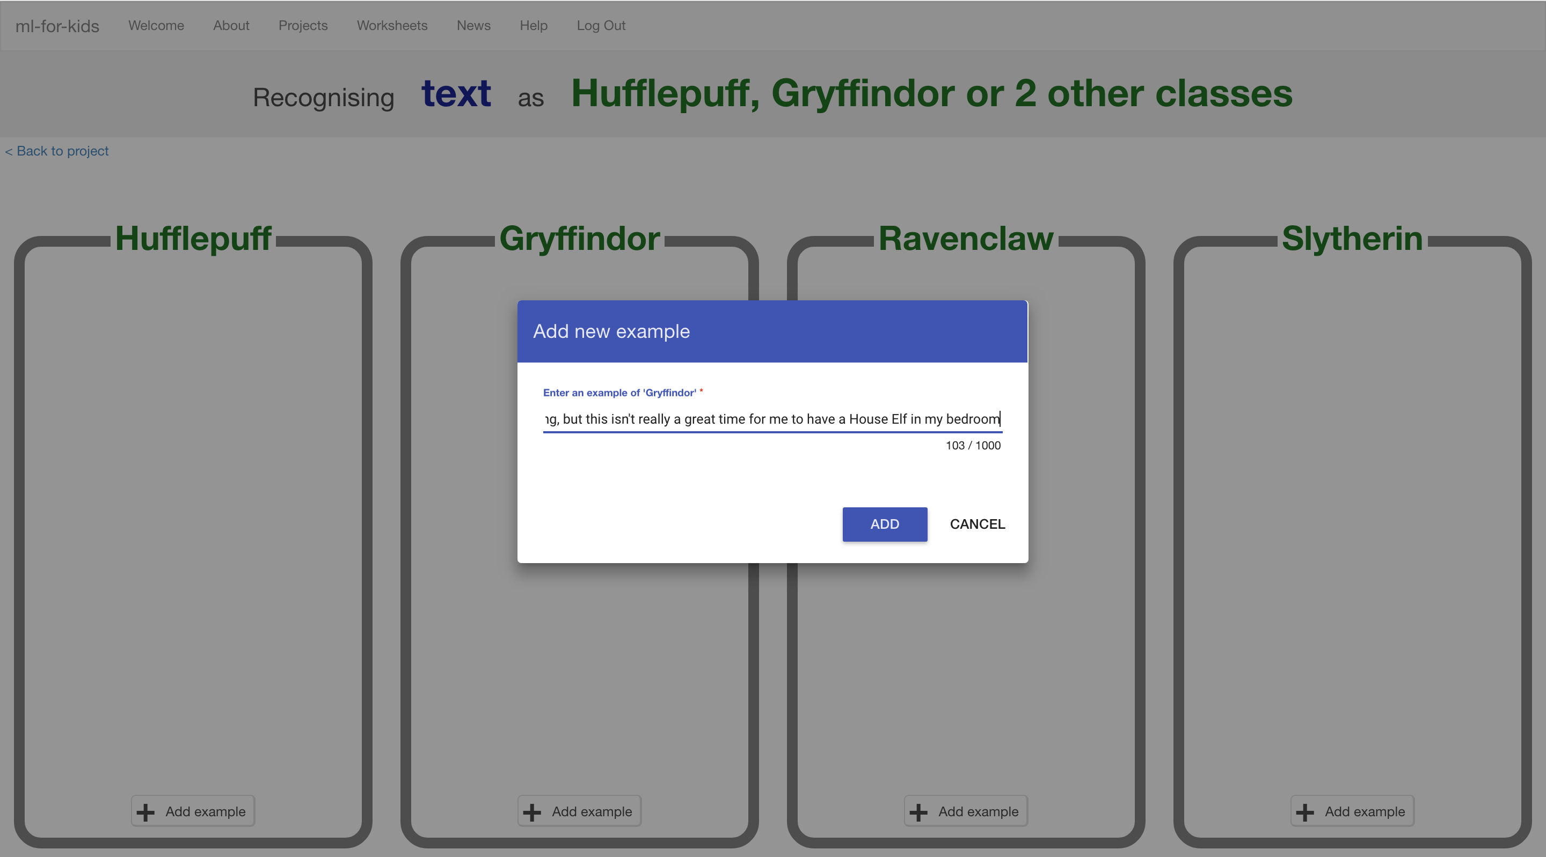

1. 同樣的，使用“**+ Add example**”，輸入來自其他三個學院的書中角色說過的話。

Add quotes for characters from each of the other three school houses in the same way, by clicking on “**+ Add example**”.

1. 持續蒐集各學院語錄，並新增至方框中

Keep going, collecting examples of quotes for each of the houses.   
*If your computer screen is big enough, you can press Ctrl and – (the dash/minus key) at the same time to fit more on the screen.*   
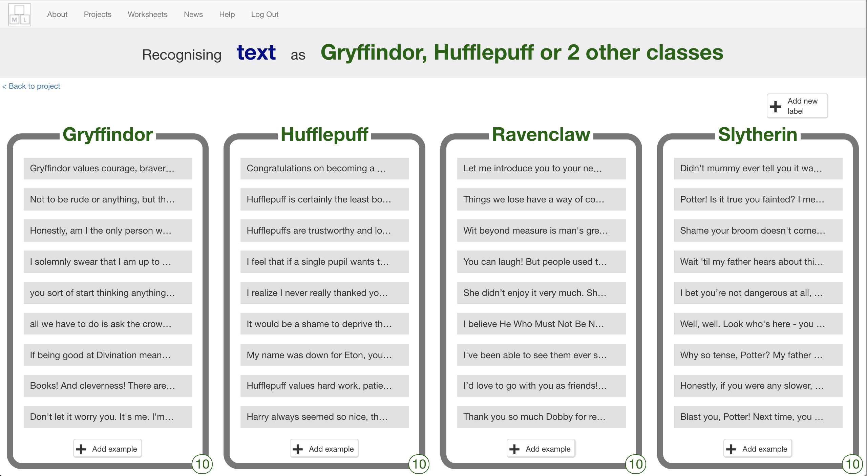

1. 你的同學也會把蒐集到的資料加進同一個訓練框裡，但你在此時並不會看到。

*重新整理頁面以看到全班所蒐集到的資料*

Your classmates will also be adding quotes to the same training buckets as you, but they won’t show up while you’ve got the page open.   
*Refresh the page to see all the training so far from the whole class.*

1. 重複上述步驟，直到你們班搜集到足夠的範例。

除非老師跟你們說可以繼續下個步驟，否則請繼續搜集。

Keep going until your class have collected enough examples.   
**Don’t move past this step until your teacher tells you that it is time to move on.**

**教師教學指南：訓練一個機器學習模型**

**Teacher / Group leader instructions : Train a ML model**

**目標：掌握班級進度，以及訓練一個機器學習模型**

**Objective:** Monitor class progress & train a machine learning model

1. 點選上方清單中的 ”**Projects**” 按鈕

Click on “**Projects**” in the top menu bar

1. 點選專案 “Sorting Hat”

Click on the “Sorting Hat” project

1. 點選“Learn & Test” 按鈕

Click on the “Learn & Test” button

1. 檢閱班級進度

*如果搜集的範例越多，模型應該會表現得越好。但每個學院至少需要5個範例才能建立模型。*

Review the summary of the progress the class has made  
*The more examples they collect, the better the model should perform but they need at least five examples of each house to be able to create a model at all.*  
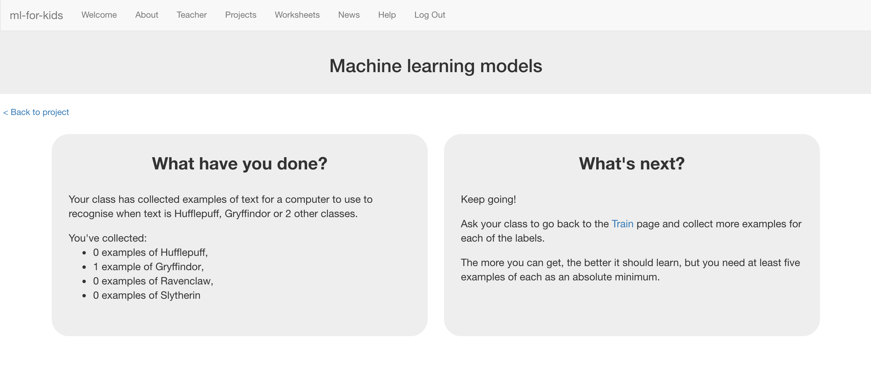

1. 如果你已經準備好繼續，點選 “**Train new machine learning model**”按鈕來

使用這些範例照片訓練一個新的模型

*這可能會花費一到兩分鐘，當完成時，網頁上的狀態會從“Training”變為“Active”*

When you’re ready to proceed, click “**Train new machine learning model**” to train a new model using their examples.  
*This may take a minute or two. The status on the page will change from “Training” to “Active” once it has finished.*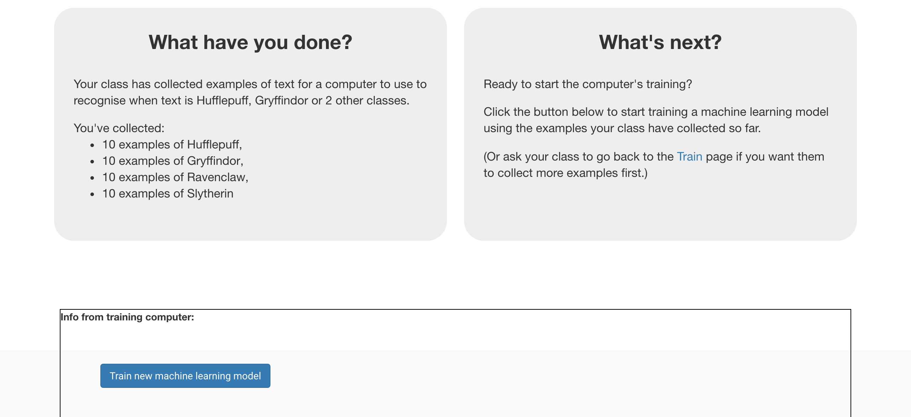

1. 當一切就緒後，你可以告訴學生繼續之後的動作

Once it is ready, you can tell the class it’s time to move on.

**給學生：實作步驟**

**Student instructions**

1. 點選“**< Back to project**”按鈕

Click on the **“< Back to project**” link.

1. 你的老師已經使用你們所蒐集到的範例照片建立了一個機器學

習模型，點選“**Learn & Test**”按鈕。

Your teacher has used the examples your class collected to train a machine learning model. To try it out click on “**Learn & Test**”

1. 當訓練完成後，會出現一個文字框。

測試一下這個模型，看看電腦學到些什麼。

*使用電腦沒看過的句子測試，不要用電腦已經看過的句子*

As long as the training has finished, a Test box will be displayed.   
Try testing your machine learning model to see what the computer has learned.   
*Test it with example quotes that you haven’t shown the computer before.   
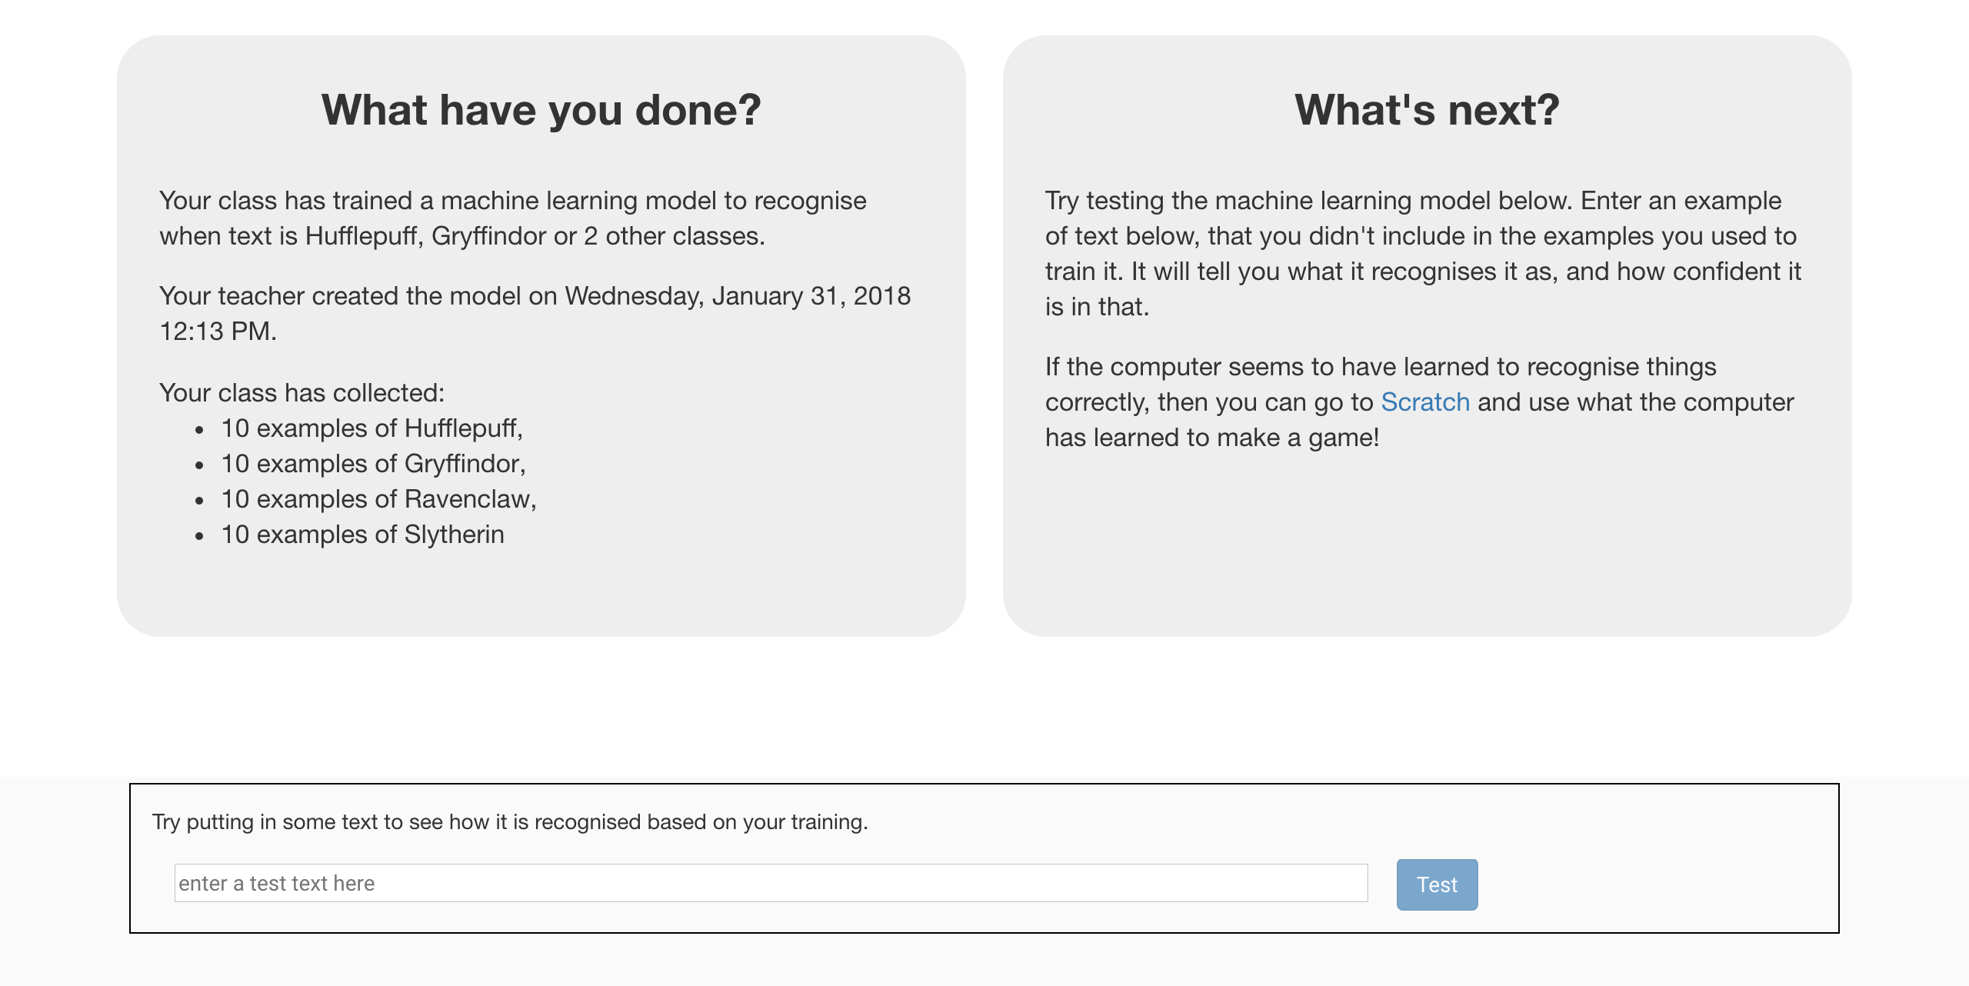*

1. 點選“**< Back to project**”按鈕

Click the **“< Back to project**” link

1. 點選“**Make**”按鈕

Click the “**Make**” button

1. 點選“**Scratch**”按鈕

Click the “**Scratch**” button

**到目前為止，你做了哪些事情？**

**What have you done so far?**

你開始訓練電腦分辨哈利波特中不同角色說話的風格。

You’ve started to train a computer to recognise the use of language by different characters in the Harry Potter books.

這些範例被拿來訓練一個機器學習『模型』。

These examples are being used to train a machine learning “model”.

這就是所謂的『監督式學習』(supervised learning)，因為你給電腦訓練用的範例都確保是正確的，就像是在監督它一樣。

This is called “supervised learning” because of the way you are supervising the computer’s training.

電腦會從範例中尋找共通的模式，例如遣詞用字，或者是說話風格。

The computer will learn from patterns in the examples you’ve given it, such as the choice of words, and the way that sentences are structured.

這些共通的模式可以用來預測書中角色以外的人適合哪個學院，就像分類帽一樣。

These will be used to be able to make predictions about people not in the book, just like the Sorting Hat does.

如果你的模型現在看起來很糟，別擔心，那是因為現在只有蒐集一點點範例，電腦學不到太多東西。想要讓模型更好，你需要蒐集很多範例來訓練電腦。

Don’t worry if your model seems to get a lot wrong. With only a handful of examples of each house, the computer won’t have had very much to learn from yet. If you were doing this for real, you’d be collecting dozens or hundreds of examples for the computer to train on.

1. 點選“**Open in Scratch**”按鈕

Click the “**Open in Scratch**” button   
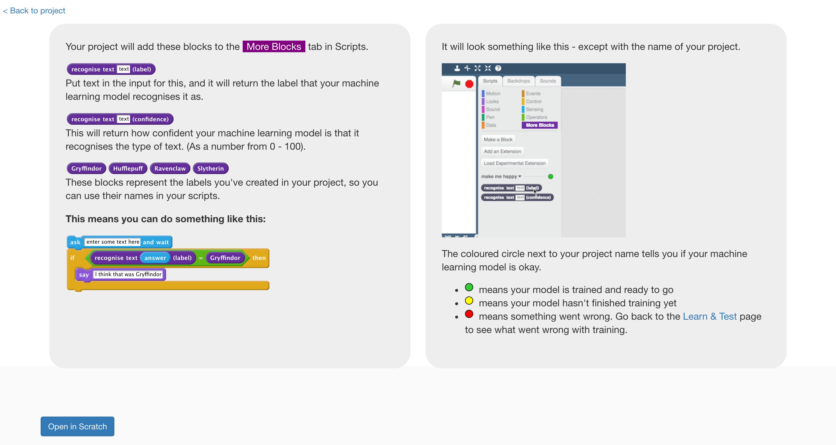

**小技巧**

**Tips**

**多一點範例！**

**More examples!**

當你給越多範例，電腦就應該能更正確的辨別不同學院說話的風格。

The more examples you give it, the better the computer should get at recognising what the different school houses have in common.

**盡可能蒐集相同數量的範例**

**Try and be even**

試著讓各學院的範例數量一樣多。

Try and come up with roughly the same number of examples for each House.

這可能會有點困難，特別是Hufflepuff學院！但盡量試著別只著重在Gryffindor和Slytherin學院

This can be difficult – particularly for Hufflepuff! But try not to focus only on Gryffindor and Slytherin.

如果你其中一個學院的範例特別多，那麼電腦可能容易判別為這間學院，這會影響電腦的預測。

If you have a lot of examples for some houses, and not the others, the computer might learn that being in those houses is more likely than the others. That would probably affect the predictions that it makes.

**線上搜尋**

**Quotes online**

如果你身邊沒有哈利波特的書籍，試試從網路上尋找你喜歡的角色說過的話。

If you’re struggling, or you don’t have a copy of a Harry Potter book available, try searching for quotes of your favourite characters online.

1. *你應該會在專案中的『更多積木』(More blocks)區看到新積木*

You should see blocks in “More blocks” section from your project.  
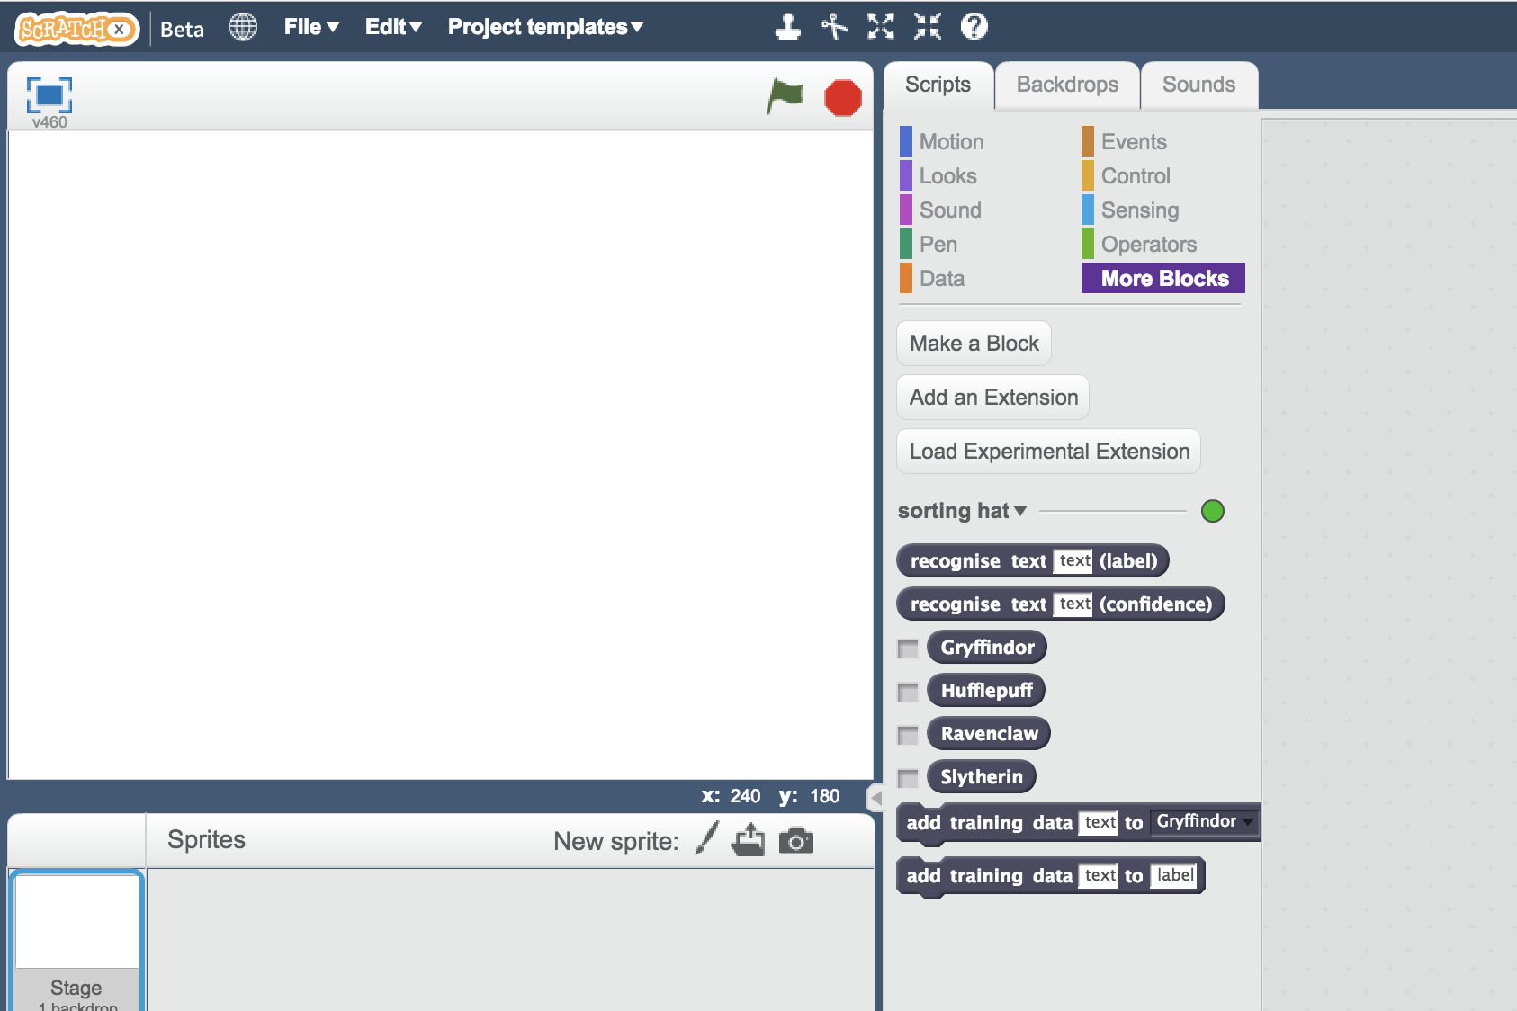

1. 點選畫筆，要畫出一個新的角色

Create a new sprite by clicking on the paint brush icon next to “New sprite”, just below the white canvas.

1. 畫出一頂分類帽

*如果畫不出來，可以用網路上找到的分類帽照片代替。點選畫筆旁的資料夾圖示，上傳分類帽的檔案。*

Draw a Sorting Hat  
*If you really don’t like drawing, you could find a picture of the Sorting Hat online, and use that instead. Click on the folder icon next to the paintbrush to import a sprite from a file.*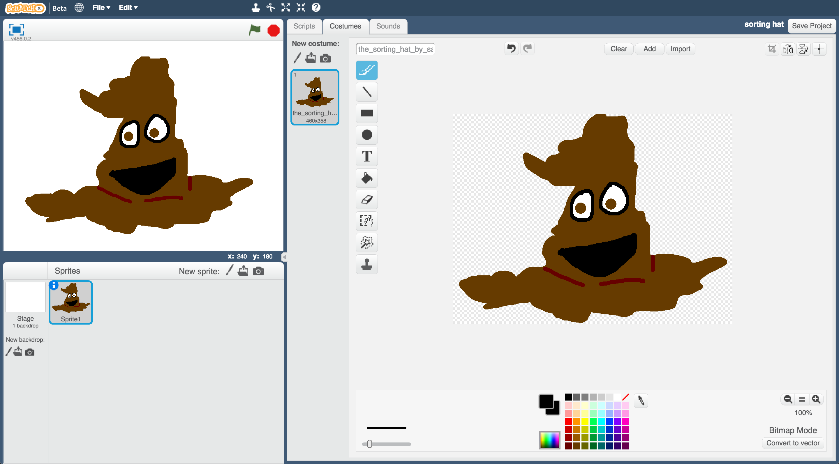

1. 點選『程式』，拖曳程式積木（如下圖）

Click the “**Scripts**” tab, and enter the following script.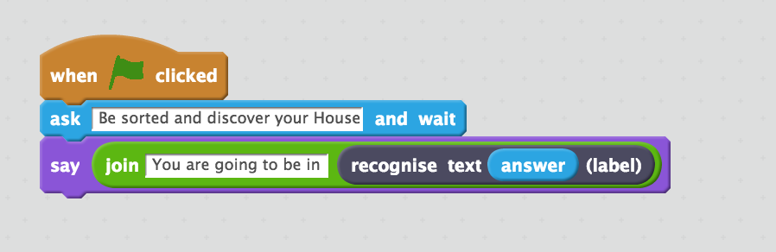

1. 存檔

點選檔案，再點選儲存專案

Save your project  
*Click* ***File*** *->* ***Save* *Project***

1. 開始測試！點擊綠旗，並輸入一條訊息。

*輸入你想說的話，或者你曾經說過的話，看看分類帽會把你分到哪個學院！*

*接著換輸入你朋友說的話，看他會被分到哪個學院吧。*

Test your script!   
Click on the **green flag**, and type in a message.  *Try typing in something that you would say, or something you have said and see which House the Sorting Hat would put you in!  
Try it on your friends and see what House the Hat would put them in.*

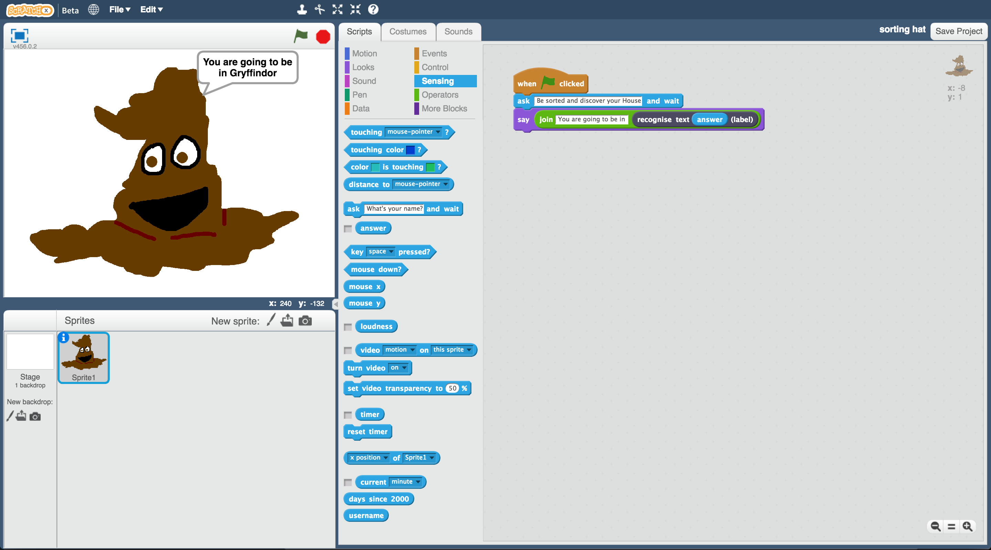

此專案靈感來自Ryan Anderson，他和他女兒一起實作出一頂分類帽！

The idea for this project came from Ryan Anderson, who made a real-life sorting hat with his daughter!

他們採用將語音轉成文字的方法，所以可以直接對分類帽講話！當文字轉換完成後，他們用訓練完成的一個機器學習模型來決定說話的人會去哪一個學院，就像你前面做的事情一樣。

Instead of typing messages to it, they also used speech-to-text so that they could actually talk to their Hat. Once they converted people’s voices into text, they trained a machine learning model to be able to recognise which House that should be, in a similar way to you have.

如果你對Ryan的分類帽有興趣，可以觀看這個影片：<https://youtu.be/tSHoJoOOi9k>

To see what the Hat looked like in action, check out their video at

<https://youtu.be/tSHoJoOOi9k>

**你完成了什麼？**

**What have you done?**

你使用機器學習建立了一個Scratch版的哈利波特分類帽。

You’ve created a Scratch game version of the Harry Potter Sorting Hat, using machine learning.

你蒐集了書中角色說過的話當作範例，訓練電腦分辨他們各自屬於哪個學院。

You trained that machine learning model by collecting examples of quotes from characters, and telling the computer which House they are in.

你會發現要將分類帽訓練好是件困難的事，而且需要非常多範例。

You’ve seen that doing this well is difficult, and needs a lot of examples.

但即使我們只有一部分的範例，看電腦從訓練中學到什麼以及如何用學到的共通模式進行判斷依舊是件很有趣的事！

But even with a small number of examples, it’s fun to see the patterns that the computer learns, and how it tries to use that to recognise new text.

此專案靈感來自Ryan Anderson，他和她的女兒一起做出一頂分類帽！

The idea for this project came from Ryan Anderson, who made a real-life sorting hat with his daughter!

他們採用將語音轉成文字的方法，所以可以直接對分類帽講話！當文字轉換完成後訓練一個機器學習模型，就像你前面做的事情一樣。

Instead of typing messages to it, they also used speech-to-text so that they could actually talk to their Hat. Once they converted people’s voices into text, they trained a machine learning model to be able to recognise which House that should be, in a similar way to you have.

如果你對Ryan的分類帽有興趣，可以觀看這個影片：<https://youtu.be/tSHoJoOOi9k>

To see what the Hat looked like in action, check out their video at

<https://youtu.be/tSHoJoOOi9k>